Ansible-Day-02

1)Watch ansible-02 video and write down notes.

Completed

2) Install httpd using ansible playbook, use handlers,notifiers.

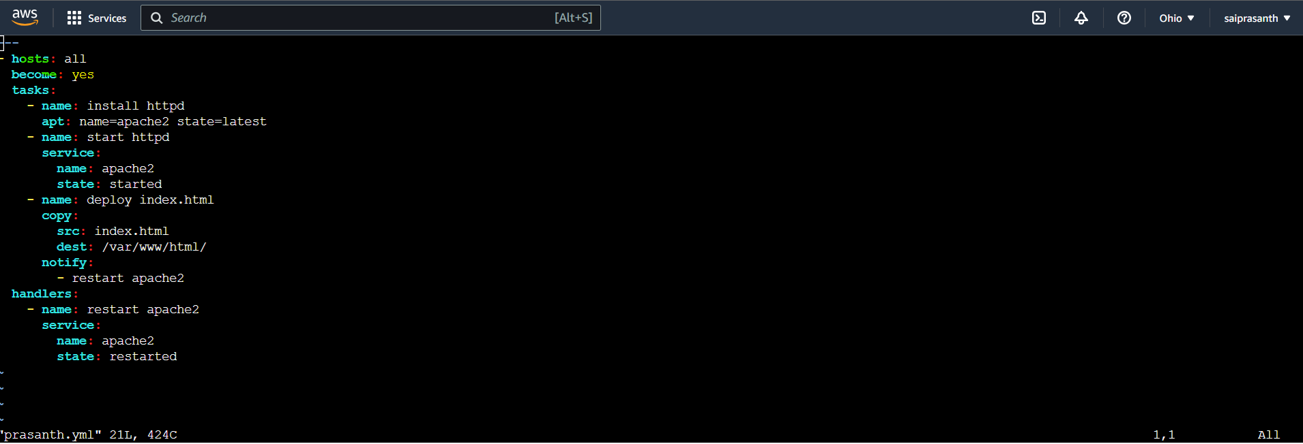

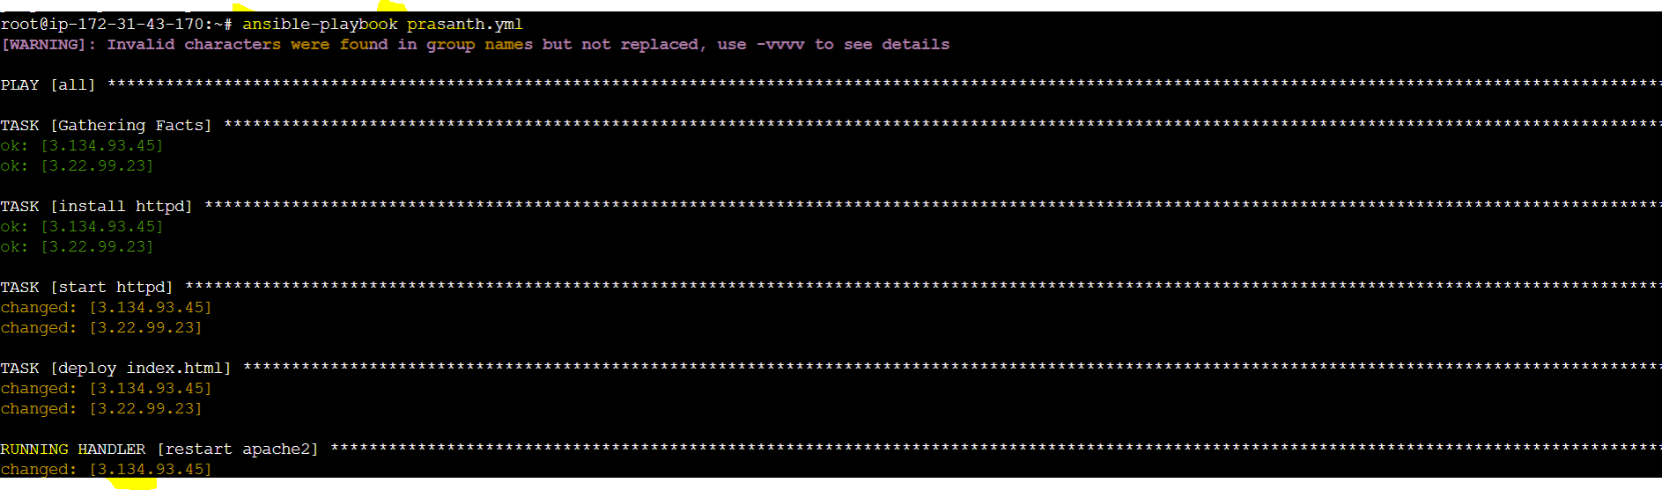 



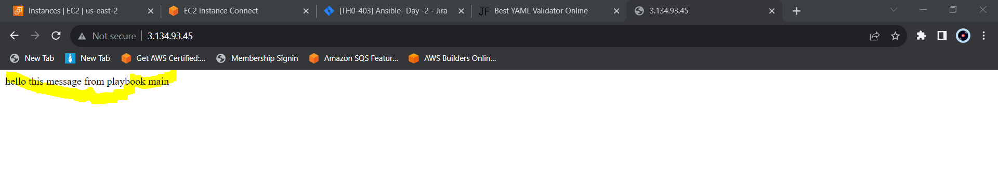

3) Write a ansible playbook to install apache tomcat.

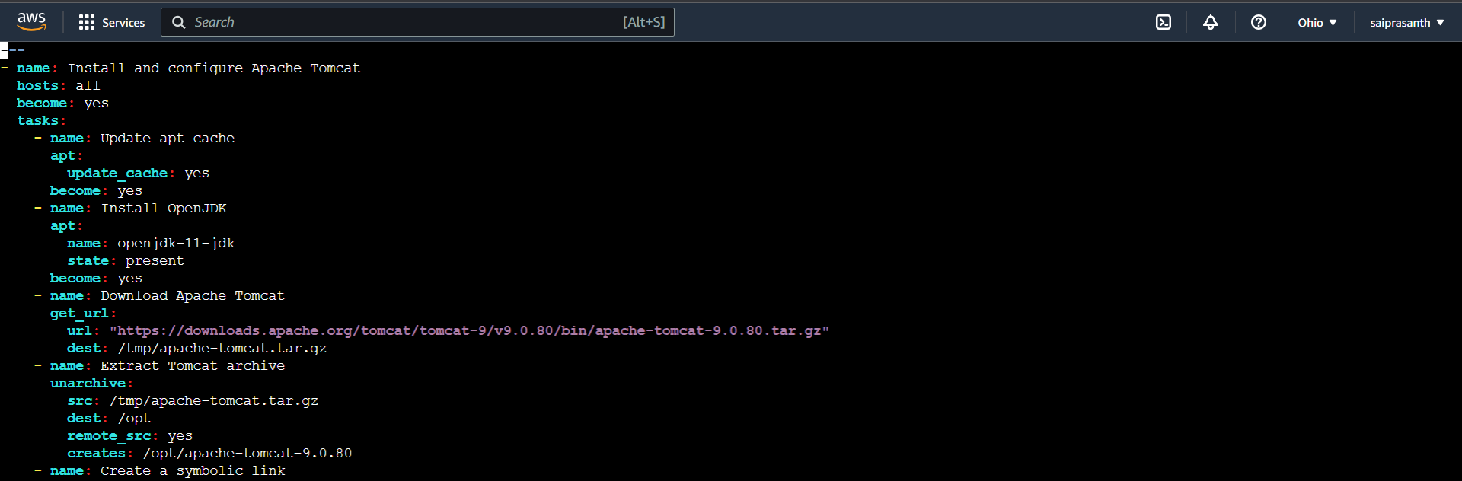 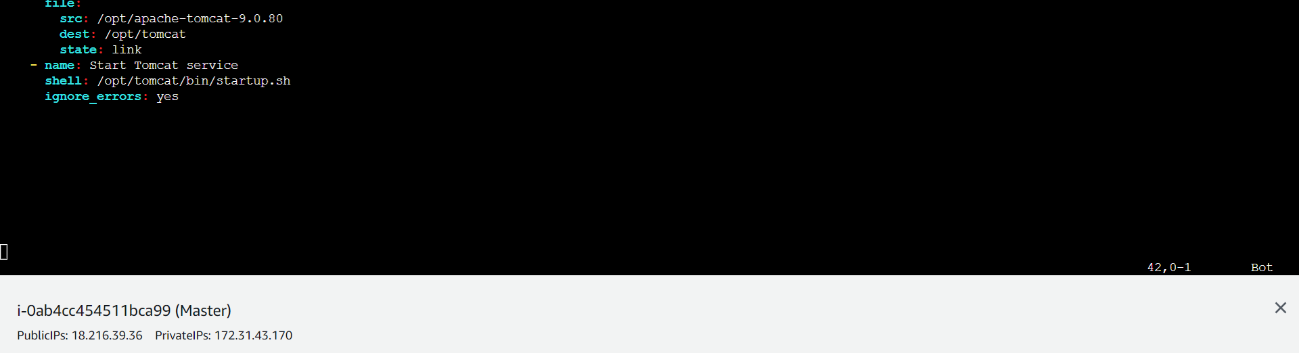 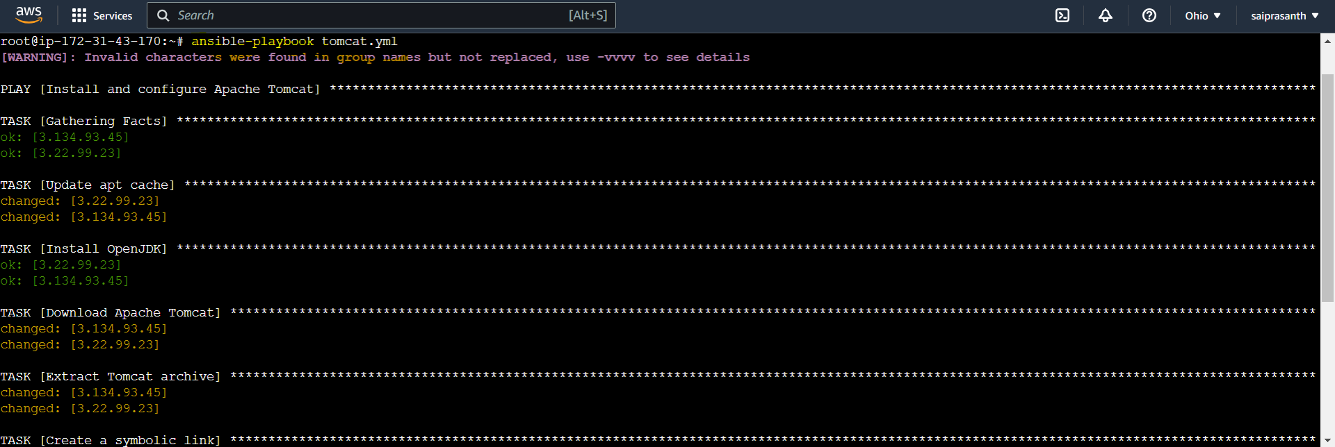 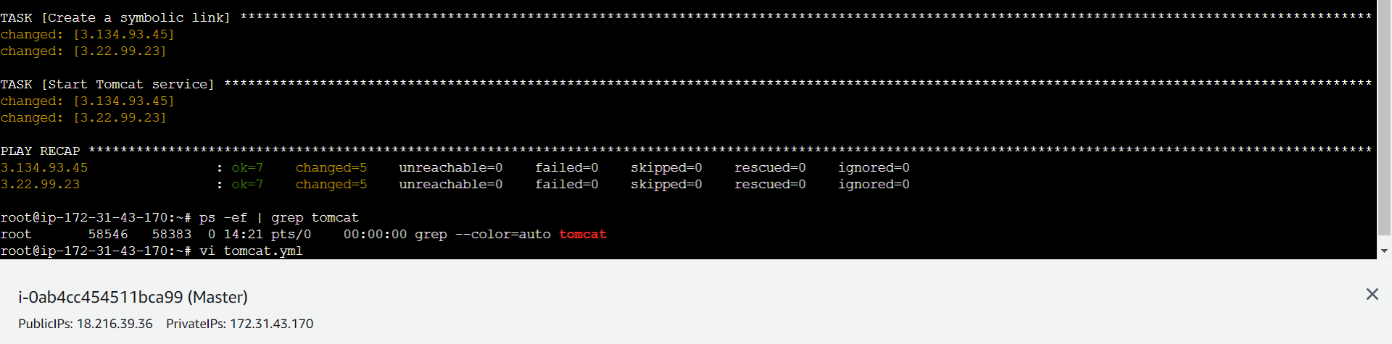

Output:worker-01

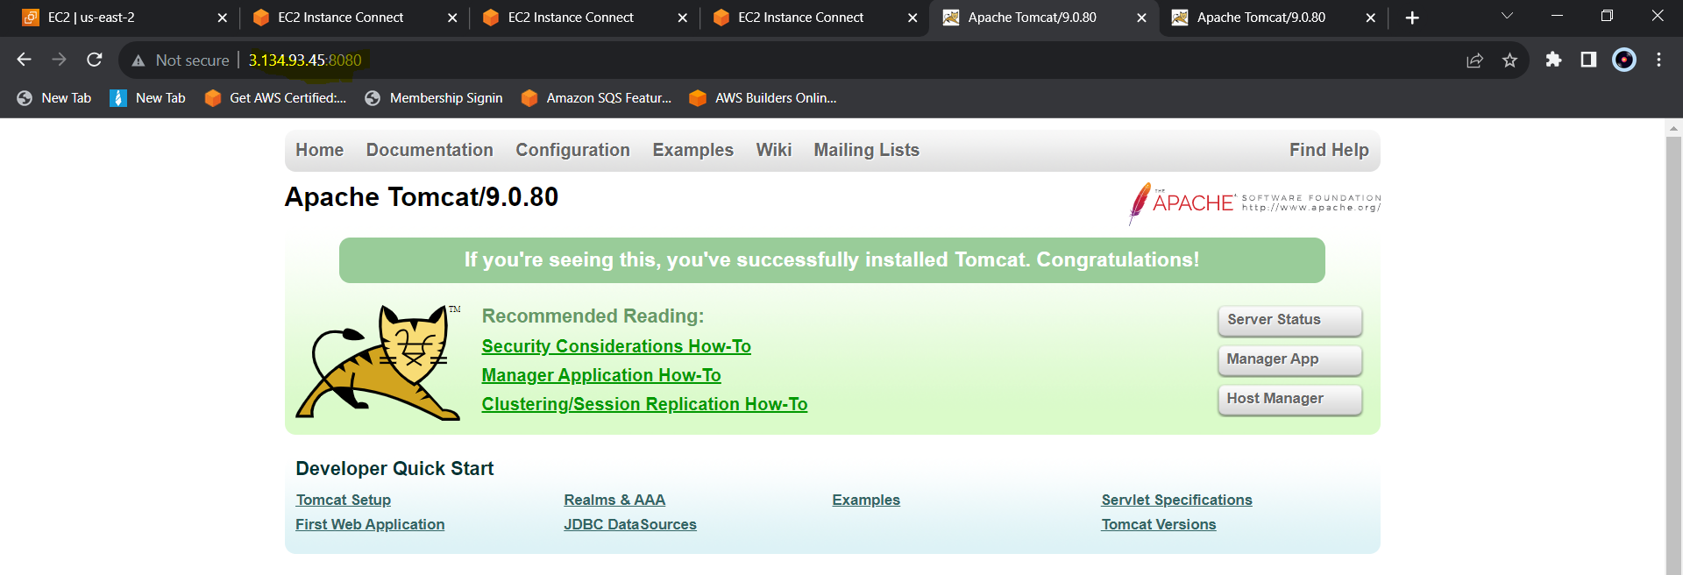

Output:worker-02

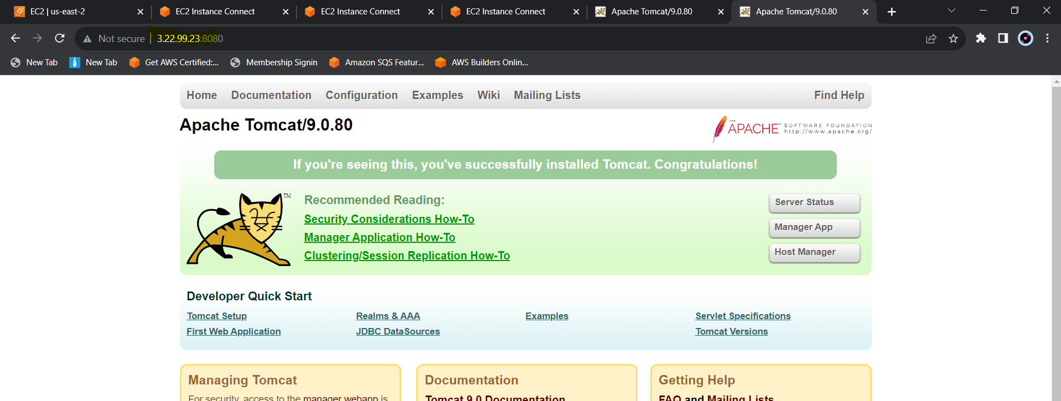

4) Write a ansible playbook to provision one ec2 on aws.

#configure aws cli in Master sever

#apt install python3-pip  
   #pip install boto3

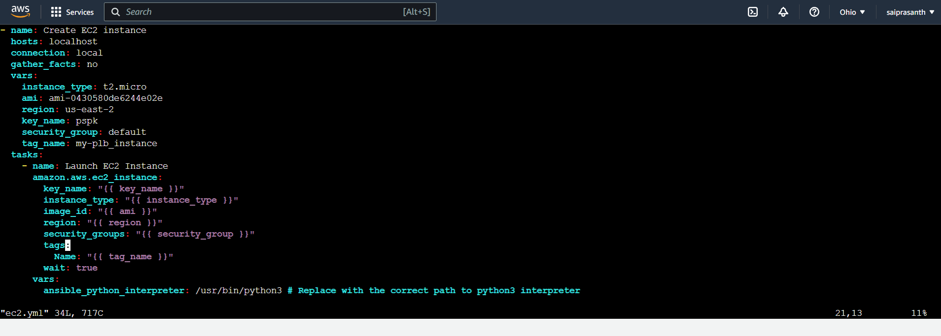

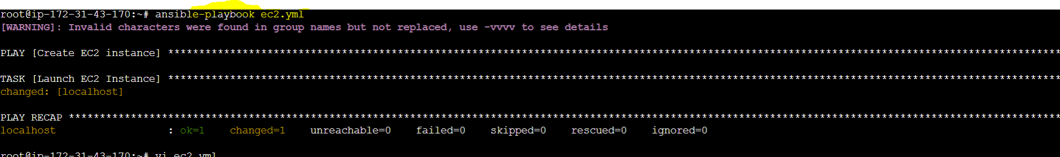 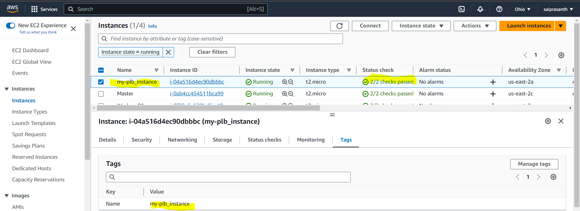

5) Write a ansible playbook to copy one file from node-1 to node-2.

6)Write a ansible playbook to create different files with different names using single playbook.

With loop concept:

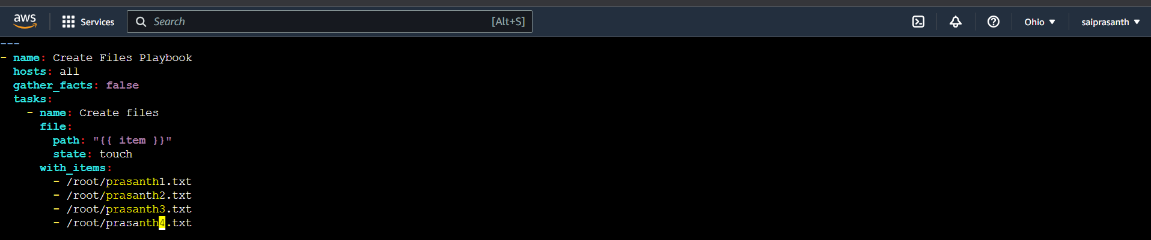

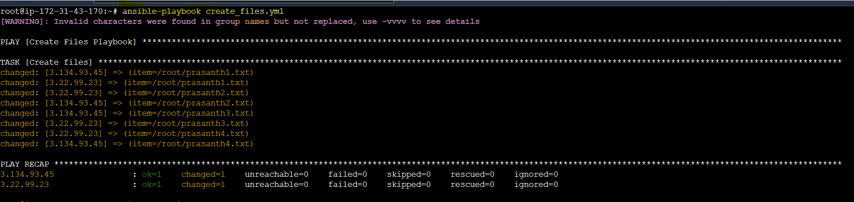 output:

Worker-01

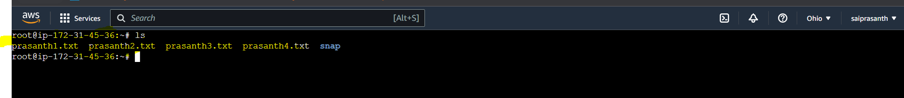

Worker-02

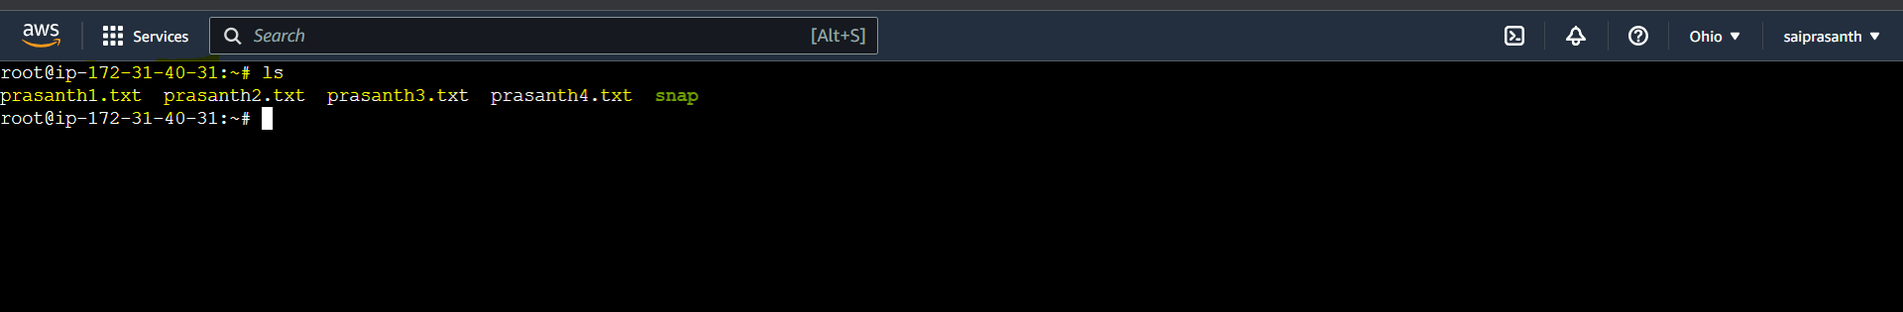

Loop: creating files 1 to 10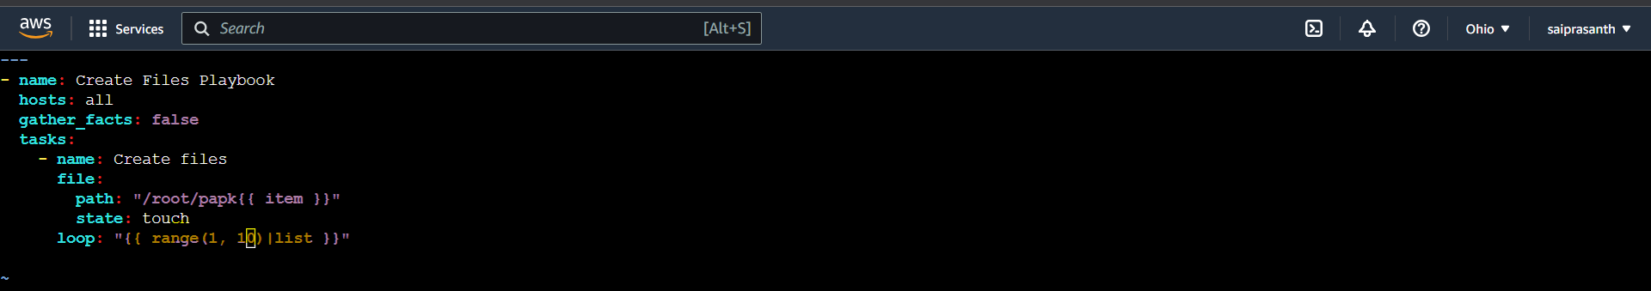

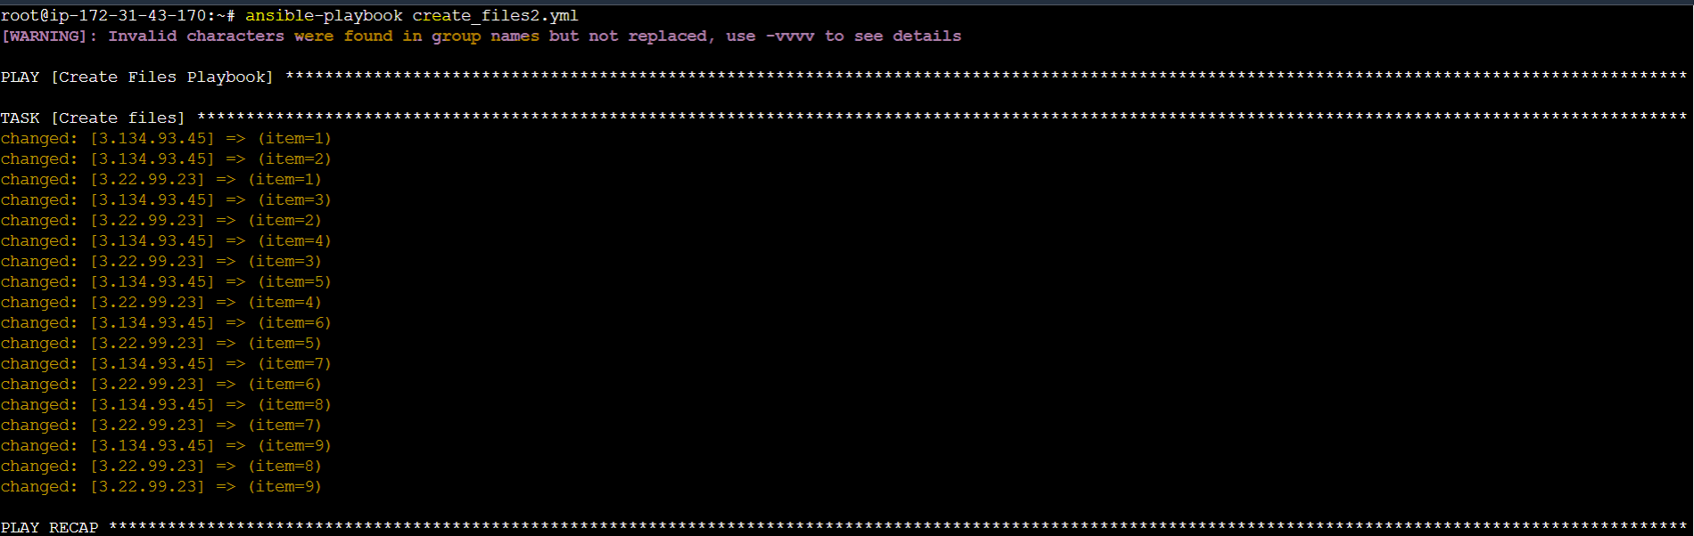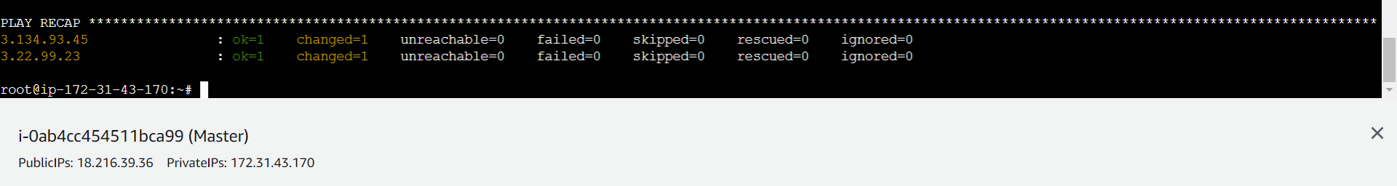

Output:

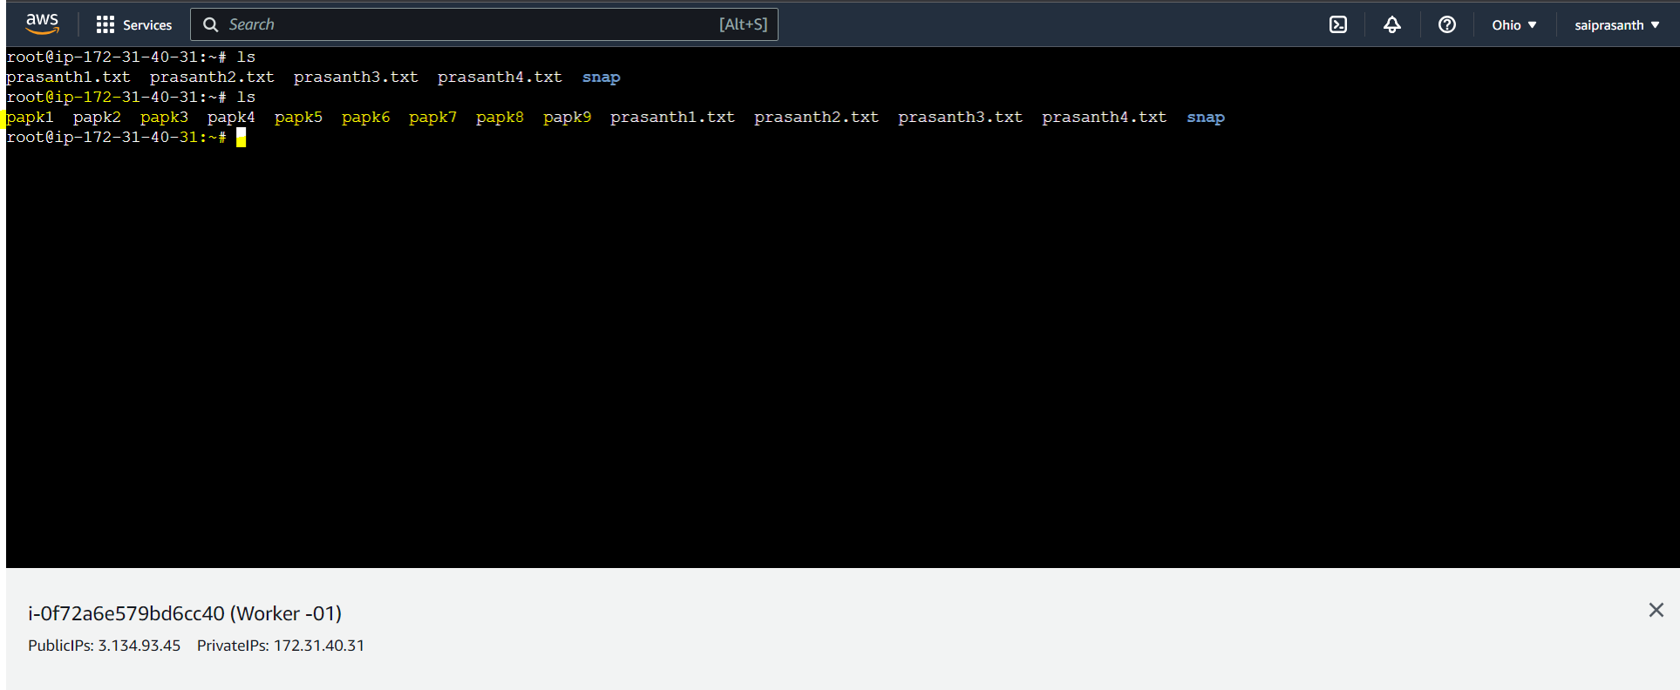

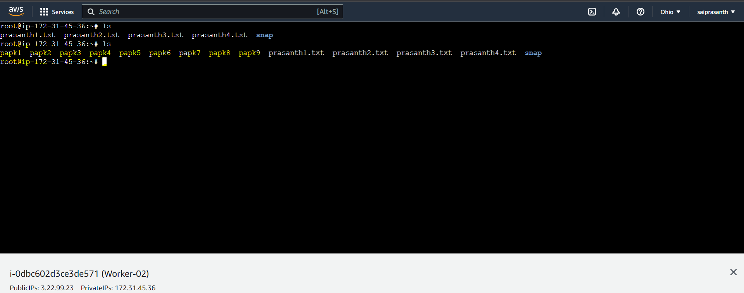

Creating multiple files with out loop

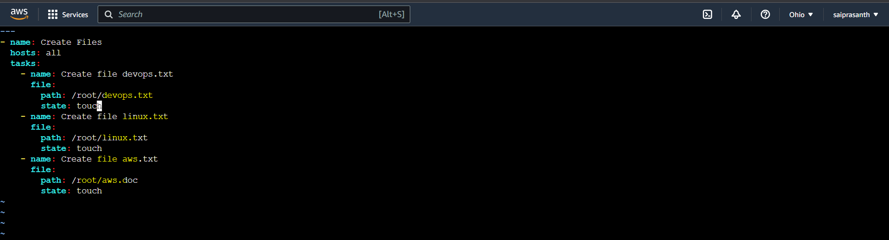

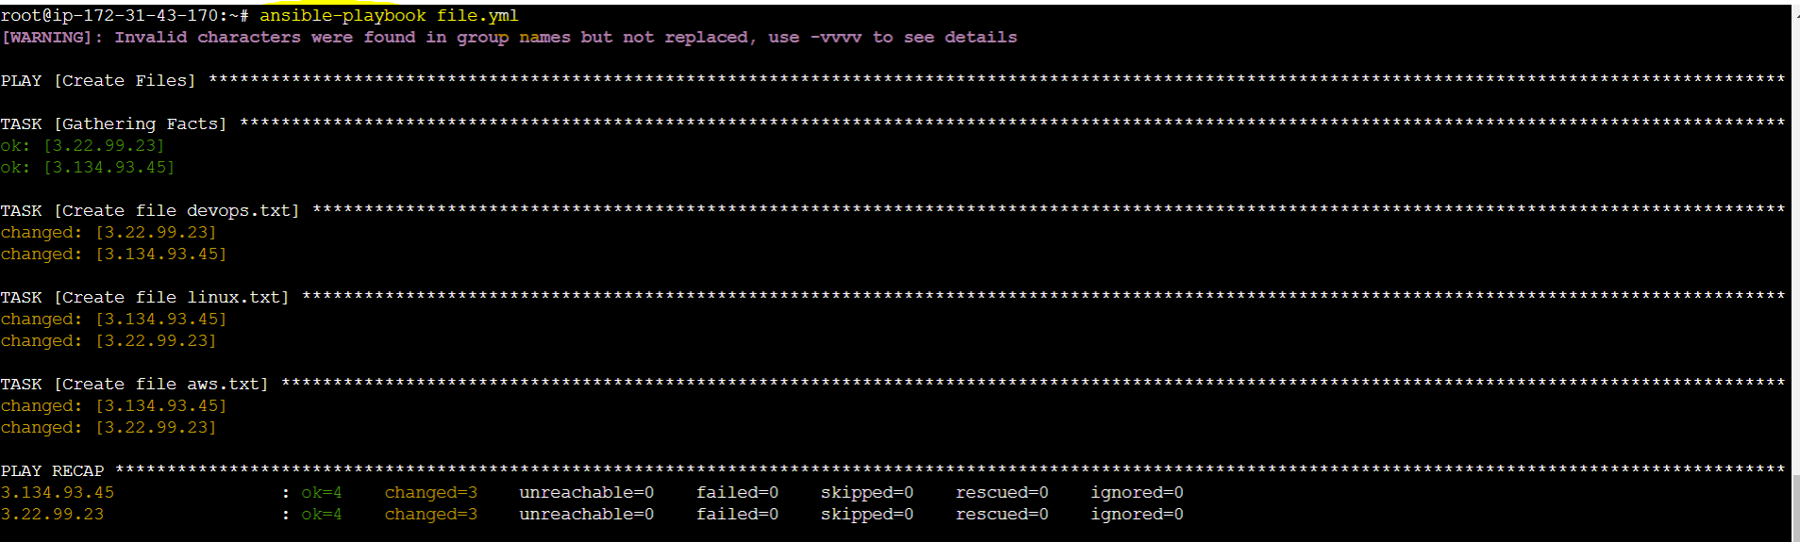

Output worker-01: 3.134.93.45

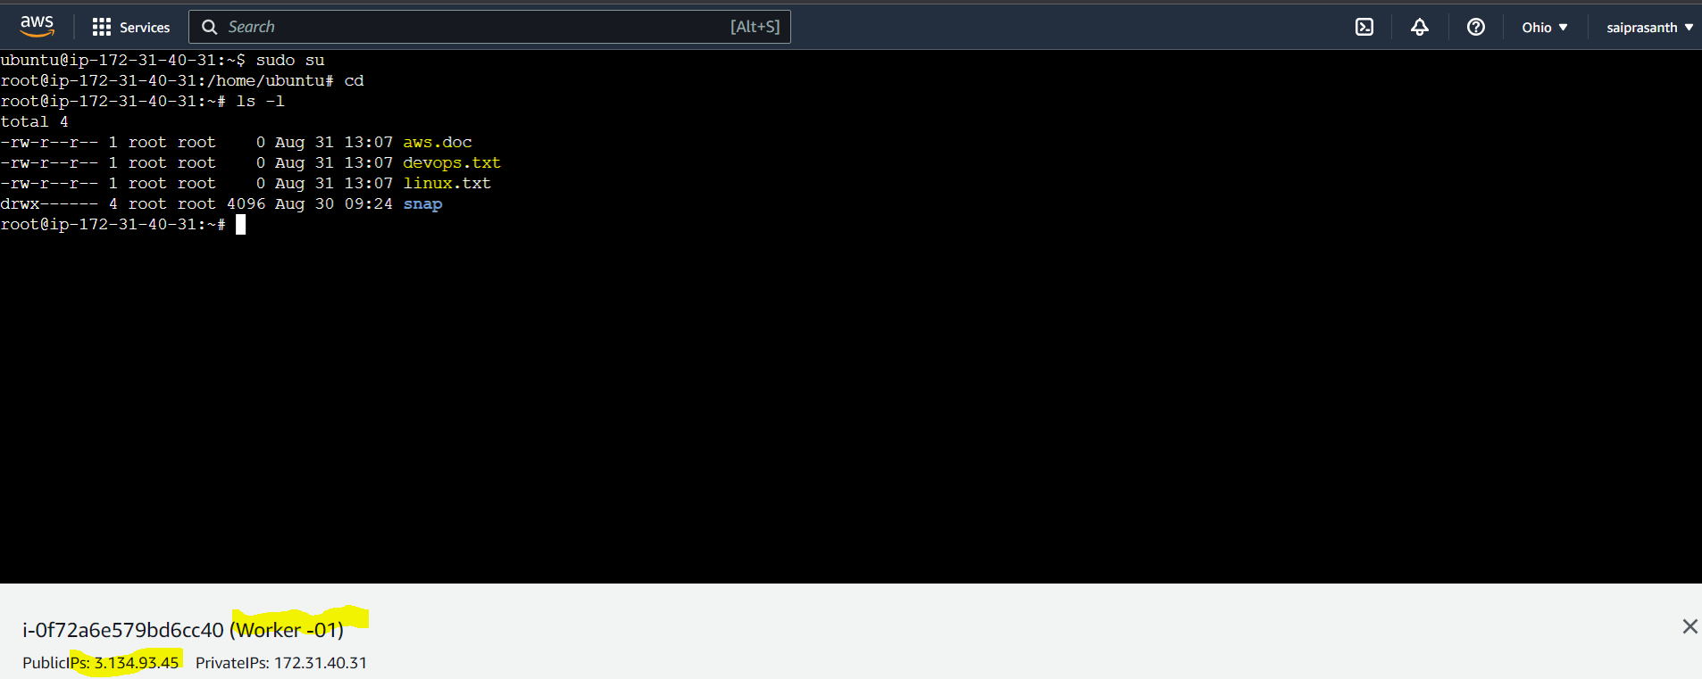

Output worker-02: 3.22.99.23

